ABSTRACT

In the dynamic landscape of mobile applications, ensuring the safety of users has become increasingly crucial. This project introduces a robust fraud detection framework that focuses on Assessing the legitimacy of mobile apps. primarily through the analysis of user reviews. The effectiveness of three predictive models – Decision Tree classifier, Logistic Regression, and Naive Bayes – is thoroughly compared using essential performance metrics such as F1 score, Recall, Precision, and Accuracy. The analysis reveals that the Decision Tree model outperforms the others, boasting an impressive 85% accuracy rate, accompanied by an F1 score of 0.815, a Recall value of 0.85, and a precision of 0.87. In conclusion, in an era where the proliferation of fraudulent apps poses a significant threat to user security, our project offers a comprehensive solution. By leveraging the power of machine learning and data analysis, this framework provides an effective means of determining the authenticity of mobile applications. The findings not only underscore the superiority of the proposed model but also lay the foundation for a standardized approach to fraud detection in app stores, enhancing overall security protocols.

CHAPTER 1
INTRODUCTION
  - Introduction:
The proliferation of mobile phones and the rapid advancement of technology have led to a significant surge in the usage of mobile applications. Platforms such as Android and iOS offer diverse play store apps, which have become integral to daily life, marketing, and business intelligence. This growth, however, has introduced challenges, particularly in maintaining quality standards and ensuring authentic user feedback. The competition among companies and developers to gain user trust and app success has led to novel strategies, including manipulative practices like fraudulent reviews and ratings. This paper addresses the need for an automated method to identify and mitigate such fraudulent behaviors, enhancing the reliability of user feedback and fostering healthier app marketplace dynamics.
1.2 Objective:
The primary goal of this study is to develop an automated framework that detects and flags suspicious and fraudulent app reviews and ratings. By accurately identifying and filtering out inauthentic feedback, this system aims to provide app store users with reliable and accurate insights into the quality of applications, thereby promoting a fair and competitive app marketplace.
1.3 Technical Approach:
To achieve the objective, we propose a multi-faceted technical approach:
- Data Collection and Preprocessing: The study involves collecting a diverse dataset of app reviews and ratings from various platforms. Preprocessing techniques, including text cleaning and sentiment analysis, are applied to prepare the data for analysis.
- Machine Learning Model Implementation: A machine learning model, specifically a hybrid of Natural Language Processing (NLP) and anomaly detection techniques, is developed. This model is trained on genuine and fraudulent review data to learn patterns of suspicious behavior.
- Feature Engineering: Key features, such as review sentiment, linguistic patterns, user behavior, and temporal aspects, are extracted to create a comprehensive feature set that captures fraudulent activities.
- Fraud Detection and Flagging: The developed model analyzes incoming reviews and ratings, assigning a probability score to each entry. Entries with high probability scores are flagged as potentially fraudulent and are subject to further investigation.
- User Notification and App Ranking: Users are provided with notifications highlighting potentially fraudulent reviews. Additionally, this framework contributes to enhancing the overall ranking algorithm of app stores by integrating the detection results to minimize the influence of manipulated feedback.
1.4 SCOPE OF THE THESIS
The scope of the project encompasses the development of an automated system for detecting fraudulent reviews and ratings in mobile app stores. The system's goal is to improve user trust, enhance app marketplace fairness, and contribute to the overall integrity of app ecosystems.
1.5 APPLICATIONS OF THE THESIS
- By bolstering the credibility of user feedback, this approach plays a pivotal role in cultivating a healthier and more equitable app marketplace.
1.6 ORGANIZATION OF THE THESIS
- The thesis contains 8 chapters.
- The 1st chapter is about the Introduction.
- The 2nd chapter is about the Domain Overview.
- The working of a general machine learning project is discussed here.
- The 3rd chapter is about the Literature survey i.e. the previous work done in the area of intelligent health care system.
- The 4th chapter is about System Analysis which describes the Existing systems and their disadvantages and the proposed system and its advantages.
- The 5th chapter is about proposed modular implementation of the project which describes the modules present and the functionality of the project.
- The 6th chapter details the system design and project’s output screenshots.
- The 7th chapter details the project’s test cases. The thesis closes with the 8th chapter states the major conclusions and the future scope of the thesis.
CHAPTER 2
BACKGROUND CONCEPTS

2.1 INTRODUCTION
“ Comprehensive Fraud App Detection Framework” falls under the domain of Machine Learning, specifically within the subdomains of Anomaly Detection and App Security.
Here is a breakdown of the key domains involved:
2.2 Machine Learning:
This is the broader domain that deals with creating algorithms and models that allow computers to learn from data and make predictions or decisions without being explicitly programmed. In our project, we have planned to use a Decision Tree algorithm, which is a machine learning algorithm used for both classification and regression tasks.
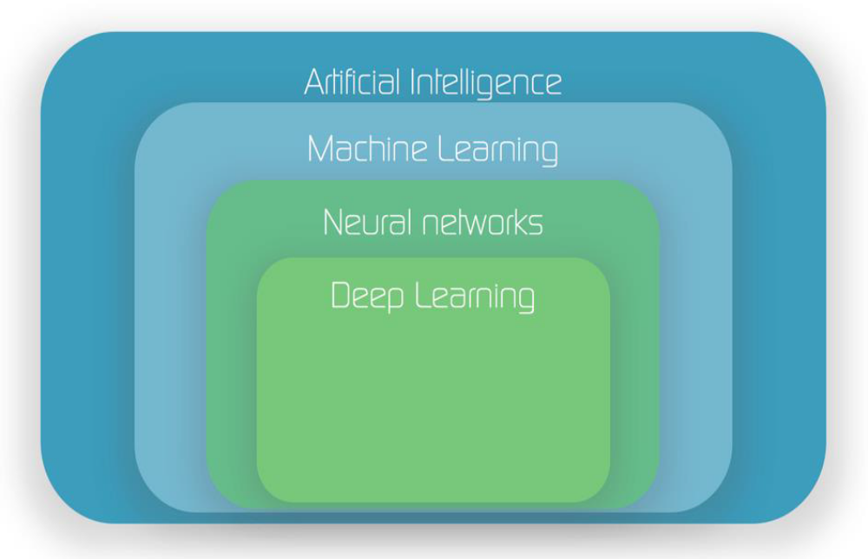
Fig 2.1 Machine Learning Workflow

    - Decision Tree:
- The Decision Tree algorithm is a powerful tool for classification tasks, which makes it well-suited for distinguishing between genuine and fraudulent apps.
- Decision Trees construct a hierarchical structure of decisions based on the features of the dataset. Each internal node represents a decision based on a specific feature, while the leaves represent the predicted class labels.
- By training a Decision Tree model on the dataset, the system learns to make informed decisions about whether an app is fraudulent or not based on the specified features such as in-app purchases, ad presence, ratings, and reviews.
- The accuracy achieved by the Decision Tree algorithm was found to be the highest among the three, reaching an impressive 85%.

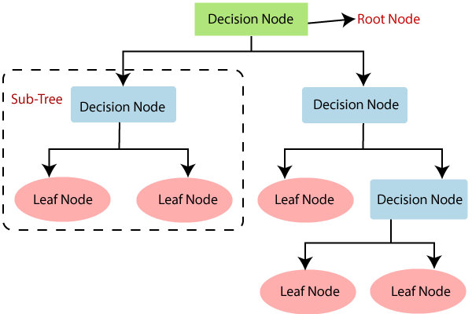
Fig 2.2 Decision Tree Classifier

2.2.2 Logistic Regression:
- Logistic Regression is a widely-used statistical method for binary classification tasks, making it suitable for predicting whether an app is fake or genuine.
- Logistic Regression models the probability of a binary outcome (in this case, fake or genuine) based on the input features.
- By fitting a Logistic Regression model to the dataset, the system estimates the coefficients for each feature, providing insights into the influence of each feature on the likelihood of an app being fraudulent.
- The Logistic Regression model yielded an accuracy of 84%, showcasing its effectiveness in distinguishing between real and fraudulent apps.
2.2.3 Naive Bayes:
- Naive Bayes is a probabilistic algorithm that assumes independence between features, making it a popular choice for text classification and other types of categorical data.
- In the context of app fraud detection, Naive Bayes calculates the probability that an app is fake or genuine based on the provided evidence, such as in-app purchases, ad presence, ratings, and reviews.
- By training a Naive Bayes model on the dataset, the system leverages probabilistic reasoning to assign a likelihood of an app being fraudulent or not.
- The Naive Bayes algorithm achieved an accuracy of 83%, demonstrating its ability to contribute to fraud detection efforts.

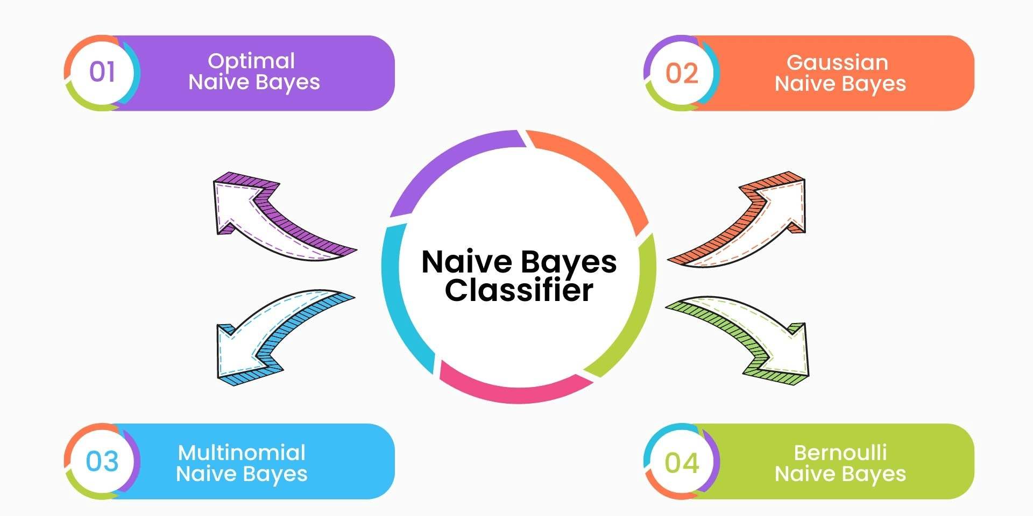
Fig 2.3 Types of Naïve bayes

Divided the dataset, allocating 75% for training and 25% for testing purposes. Constructed models using three different algorithms: Decision Tree, Naive Bayes, and Logistic Regression. After thorough comparison, identified Decision Tree as the highest-performing model based on accuracy. Evaluated and compared the accuracy of Naive Bayes (83%), Logistic Regression (84%), and Decision Tree (85%) algorithms.
Anomaly Detection: Anomaly detection is a subdomain of machine learning focused on identifying patterns that do not conform to expected behavior. In our case, we would be using machine learning techniques to identify potentially fraudulent or malicious apps on the Google Play Store. Decision Trees can be used to classify apps as either legitimate or potentially fraudulent based on their features.
App Security: This domain revolves around ensuring the security and integrity of applications, especially in cases like app stores where malicious apps can harm users. By using machine learning and decision trees, attempting to create a system that can automatically detect apps that might engage in fraudulent activities or compromise user security.
Google Play Store: This is the platform where Android users can discover, download, and install applications. Analyzing and detecting fraud in Google Play Store apps is a specific application of machine learning and app security.

CHAPTER 3
LITERATURE SURVEY
3.1 INTRODUCTION
This chapter presents information related to the sources and websites which were referred to during the “Comprehensive Fraud App Detection Framework”, This survey navigates through various facets of the problem domain, including the different types of fraudulent activities observed in app reviews, the methodologies employed to detect and combat such activities, and the ethical considerations surrounding user privacy and data security. The survey also examines the pivotal role of machine learning and Natural Language Processing (NLP) techniques in analyzing textual reviews, sentiment patterns, and user behavior to differentiate between authentic and fraudulent feedback.
Title: Detection Of Fraud Ranking For Mobile App Using IP Address Recognition Technique
Fraudulent activity in mobile app market means intruders or app developers use shady means to increase their app rating to bring their app in top 20 list to inflate their app sale. Knowledge engineering domain usually uses the methodologies to extract the useful knowledge from the given large data. Ongoing rapid growths of online data have created the need of KDD. Also ongoing rapid growth of online rating and review system to the app, make fraud app has been launched in the mobile market and let them be downloaded and used by many users. The fraud mobile app is not worth to use and wasting device memory. Sometimes such app is created with malicious software which is harmful to the device.
To avoid this situation the fraud app should be find out. In existing work, fraud rankings are detected by applying the mining algorithm in app review. Local anomaly was detected instead of global anomaly. The analysis had been done reported. Human evaluators evaluated and produce the result. Time complexity is more to evaluate. To overcome this drawback, FRDS is proposed. To detect the fraud app, app’s reviews should be checked. To check whether the app reviews are fraud or not, the Fraud Ranking Detection System is proposed. In the mobile market, each mobile has its own unique IP Address. Hence, each user has unique IP Address. When giving the reviews to app, user IP Address is extracted by using the IP Address recognition technique. So that, from one IP Address number of reviews cannot be provided to same app. In this way fraud review is prevented in proposed work. This approach decreases the evaluation time of the result; hence it is efficient than the existing approach. Index Terms Detecting Fraud Ranking, Ratings and Reviews, Aggregation method

Title: “An enhanced mining leading session algorithm for fraud app detection in mobile applications”
Now days, mobile App is a very popular and well-known concept due to the rapid advancement in the mobile technology and mobile devices. Due to the large number of mobile Apps, ranking fraud is the key challenge in front of the mobile App market. Ranking fraud refers to fraudulent or vulnerable activities which have a purpose of bumping up the Apps in the popularity list. In fact, it becomes more and more frequent for App developers to use tricky means, like increasing their Apps’ sales or posting fake App ratings, to commit ranking fraud.
While the importance and necessity of preventing ranking fraud has been widely recognized. After understanding the details of ranking fraud and the need of ranking fraud detection, the paper proposes a ranking fraud detection system for mobile Apps. The proposed system mines the active periods such as leading sessions of mobile apps to accurately locate the ranking fraud. These leading sessions can be useful for detecting the local anomaly instead of global anomaly of App rankings. Besides this, by modeling Apps ranking, rating and review behaviors using statistical hypotheses tests, we investigate three types of evidences, they are ranking based evidences, rating based evidences and review based evidences. Furthermore, we propose an aggregation method based on optimization to integrate all the evidences for fraud detection.
Finally, the proposed system will be evaluated with real-world App data which is to be collected from the App Store for a long time period.

Title: “A Methodology to Detect Fraud Apps Using Sentiment Analysis”
In Today’s world, smart phone is very important in our daily life. In today’s Scenario everyone is using smart phone. Nowadays, there are numerous applications out there on web due to that user cannot continuously get correct or true reviews concerning the merchandise on web. There are so many fraud applications on the internet. The growth of apps was increased by 1.6 million at App Store and Go ogle Play. There are many apps from which any app can be fraud, so the identification of true app is needed. Our fraud app detection application will help user to identify which application is true. Our main target is to detect fraud app because there is huge no of mobile apps. By analyzing admin declare app fraud app and also based on user comment evidence we give rating.

Title: “Detection of fraud apps using sentiment analysis”
Rank misrepresentation in the portable Application advertise alludes to extortion/misleading exercises whose lone object is to have a reason for hitting up the Applications in the prominence list. It turns out to be more incessant for Application designers to utilize terrible means, for example, expanding their Application deals or posting false App evaluations, to confer positioning extortion.It is vital to avoid positioning fraud as there is restricted comprehension and research in this field. Up till now, in this paper, we have given a comprehensive perspective of positioning misrepresentation and recommended positioning extortion identification framework.

Title: “A Survey of Sentiment Analysis techniques”
Sentiment analysis is an application of natural language processing. It is also known as emotion extraction or opinion mining. This is a very popular field of research in text mining. The basic idea is to find the polarity of the text and classify it into positive, negative or neutral. It helps in human decision making. To perform sentiment analysis, one has to perform various tasks like subjectivity detection, sentiment classification, aspect term extraction, feature extraction etc. This paper presents the survey of main approaches used for sentiment classification.

Title: “Detecting Spam Web pages through Topic and Semantics Analysis”
Web spam is an illegal and immoral way to increase the ranking of web pages by deceiving search engine algorithms. Therefore, different methods have been proposed to detect and improve the quality of results. Since a web page can be viewed from two aspects of the content and the link, the number of extracting features is high. Thus, selection of features with high separating ability can be considered as a pre processing step in order to decrease computational time and cost. In this study, a new backward elimination approach is proposed for feature selection. The main idea of this method is measuring the impact of eliminating a set of features on the performance of a classifier instead of a single feature which is similar to the sequential backward selection. This method seeks for the largest feature subset that their omission from whole set features not only reduces the efficiency of the classifier but also improves it. Implementations on WEBSPAM-UK2007 dataset with Naive Bayes classifier show that the proposed method selects fewer features in comparison with other methods and improves the performance of the classifier in the IBA index about 7%.

Title: “Improved Discovery of Rating Fake for Cellular Apps”,
Improvising the capability of searching fake rating for mobile applications. Basically the process done is completely based on reviews and rating but while the process is going on each and every review is important so that we can get a good qualitative application. In such a situation a comprehensive view of ranking fake is provided as well as suggests a ranking fake detection for cellular applications. Specifically, the initial suggestion would be to appropriately locate the fake ranking by the means of mining of the active intervals, specifically leading classes, of cell apps. The rating of a particular application is basically given by the app user reviews which may be good or bad, post which the bad as well as good reviews are measured and observed in terms of originality post which the positive rating apps will be shown at the top on the leader board. In the meanwhile, finding the fake reviews, the near estimation of the reviews and rating percentage is calculated based on a systematic procedure. In such main sessions can be taken as advantage for detecting the nearby abnormality rather than international abnormality of App ratings. Furthermore, while making an analysis three types of evidences are found which include ranking primarily based authentication, rating based authentication and evaluate primarily based authentication by modeling Applications rating and evaluation behavior via statistical hypotheses exams. In the same manner endorsement of an optimization-based aggregation is done by the method of combining all the evidences for fake detection. Thus, in the rating on reviews are calculated by the best reviews given by the user while that same app user used that particular app and they know about the minute details of the working of the app and the structural behavior of that application.
The calculation of the proposed machine with the real time Global App information is collected from the IOS App keeping for a long period.

Title: International Journal of Advanced Research in Computer Science and Software Engineering
International Journal of Research in Engineering and Science is an open access peer-reviewed international forum for scientists involved in research to publish quality and refereed papers. Papers reporting original research or experimentally proved review work are welcome. Papers for publication are selected through peer review to ensure originality, relevance, and readability. The journal ensures a wide indexing policy to make published papers highly visible to the scientific community.

Title: In Data Mining (ICDM)
The IEEE International Conference on Data Mining (ICDM) has established itself as the world’s premier research conference in data mining. It provides an international forum for presentation of original research results, as well as exchange and dissemination of innovative and practical development experiences. The conference covers all aspects of data mining, including algorithms, software, systems, and applications. ICDM draws researchers, application developers, and practitioners from a wide range of data mining related areas such as big data, deep learning, pattern recognition, statistical and machine learning, databases, data warehousing, data visualization, knowledge-based systems, and high-performance computing. By promoting novel, high-quality research findings, and innovative solutions to challenging data mining problems, the conference seeks to advance the state-of-the-art in data mining.

Title: Efficiently Detecting and Analyzing Spam Reviews Using Live Data Feed.
Mining of opinions from product reviews, forum posts and blogs is an important research topic with many applications. However, existing research has been focused on extraction, classification and summarization of opinions from these sources. An important issue that has not been studied so far is the opinion spam or the trustworthiness of online opinions. In this paper, we study this issue in the context of product reviews. To our knowledge, there is still no published study on this topic, although Web page spam and email spam have been investigated extensively. We will see that review spam is quite different from Web page spam and email spam, and thus requires different detection techniques. Based on the analysis of 5.8 million reviews and 2.14 million reviewers from amazon.com, we show that review spam is widespread. In this paper, we first present a categorization of spam reviews and then propose several techniques to detect them.

CHAPTER 4
SYSTEM ANALYSIS AND DESIGN
4.1 Existing system:
The existing system primarily relies on customer ratings, reviews, in-app purchases, and the presence of ads as indicators to predict app authenticity. Yet, these parameters are insufficient to guarantee accurate classification. The subjective nature of reviews and ratings can lead to ambiguous conclusions. Additionally, the inclusion of in-app purchases and ads does not necessarily correlate directly with fraudulent behavior. Thus, the current system's reliance on these parameters poses significant limitations.
4.1.1 Existing System Disadvantages:
- Subjective Interpretation: The reliance on customer ratings and reviews introduces subjectivity into the assessment process. Different users may interpret and rate an app differently, making it challenging to ascertain genuine feedback from fraudulent ones.
- Limited Scope: The existing system's focus on a narrow set of parameters overlooks other potential indicators of fraudulent behavior. Malicious apps can employ tactics that bypass the current detection criteria.
- Inefficient Manual Assessment: Relying on manual assessment of each app's authenticity is impractical due to the vast number of applications available. This inefficiency hinders the ability to effectively identify and mitigate fraudulent apps.
4.2 Problem Statement:
Mobile phones are such a common requirement, it is critical that suspicious program be designated as fraud so that play store users may uniquely identify them. It will be impossible for the user to tell if the remarks or ratings that they scroll over are a scam or genuine for their advantage. By offering a comprehensive perspective of ranking fraud detection system, we propose a system that would identify such fake applications on the Play or App store.

4.3 Proposed System:
We present a comprehensive system designed to detect and identify fake applications within app stores, specifically focusing on the Google Play Store. By assessing four key features – in-app purchases, ad presence, ratings, and reviews – our system calculates the likelihood of an application being fraudulent and potentially deceiving its users.
Nevon Projects has introduced an extensive framework that not only serves as a strong foundation but also allows for future expansion by incorporating domain-specific evidence to enhance the accuracy of detecting quality fraud. This initiative stands at the forefront of advanced projects employing algorithmic techniques to expose fraudulent applications. While achieving approximately 75-80% accuracy in fraud detection, this system strives to continually improve its effectiveness.
The primary goal of our proposed system is to meticulously scrutinize Google Play Store applications to differentiate between legitimate and fraudulent ones, commonly known as spam applications. Rigorous experimental analyses were conducted using diverse methodologies to identify fraudulent or fake applications. Our system incorporates four distinct types of evidence: ad-related ratings, in-app purchases, and review-based evidence. This evidence-based approach integrates all four facets to holistically identify instances of fraud.
In this pursuit, we implemented various machine learning models, each yielding different accuracy results. Our thorough analysis revealed that our proposed method achieves an accuracy of 85%, outperforming alternative algorithms. Among these models, the decision tree algorithm stood out, demonstrating superior performance compared to other approaches like regression and naïve Bayes. The decision tree algorithm excels in solving complex separation problems, providing reliable real-time predictions, and efficiently handling non-linear datasets. Its applicability extends across diverse domains, including engineering, social planning, business, and legal contexts.
Our system, with its comprehensive approach and utilization of advanced machine learning techniques, represents a significant step forward in combating fraudulent applications. Its robust accuracy and adaptable framework contribute to the ongoing efforts to ensure the integrity and security of app marketplaces.

4.3.1 Advantages of Proposed System
The proposed system offers a range of advantages, including robust fraud detection, automated analysis, real-time decision-making user protection and a commitment to transparency. By addressing the challenges of fraudulent applications head-on, the system contributes to the overall integrity and security of app marketplaces.
4.4 SYSTEM DESIGN
4.4.1 Architecture diagram:
A pictorial representation or graphical visualization of some concepts, their principles, elements, and components that together form a system is called an architecture diagram. It is a conceptual model where the structure and functions of the system are defined. It can have various levels of abstraction defined such as conceptual abstraction where only the concepts involved in the system are depicted. Another level of abstraction is the logical abstractions which show how the concepts work by depicting the principles and key components involved in it. The physical abstraction being the low level of abstraction shows the design of all the components involved in the system. The Architecture diagram can exhibit the above mentioned 3 levels of abstractions depending on the necessity.

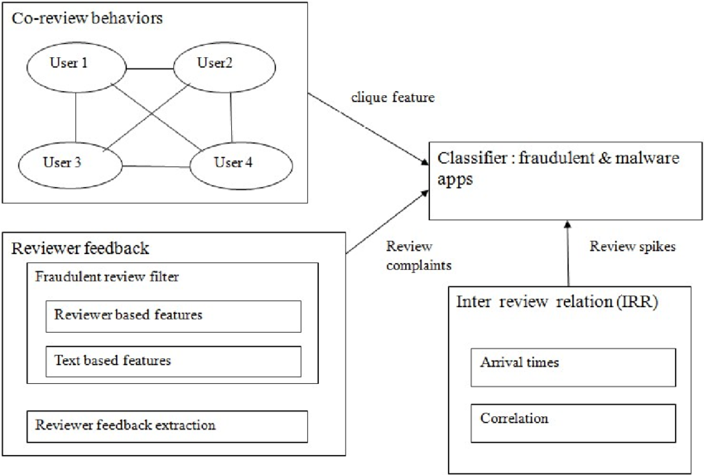
Fig 4.1 architecture diagram

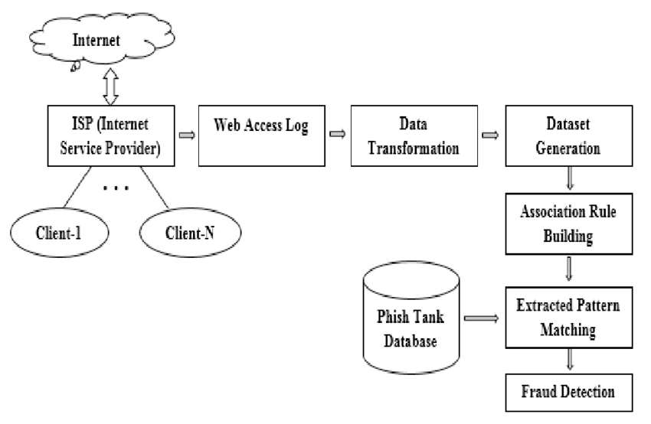
Fig 4.2 Fraud Aware Framework

4.4.2 Data flow diagram:

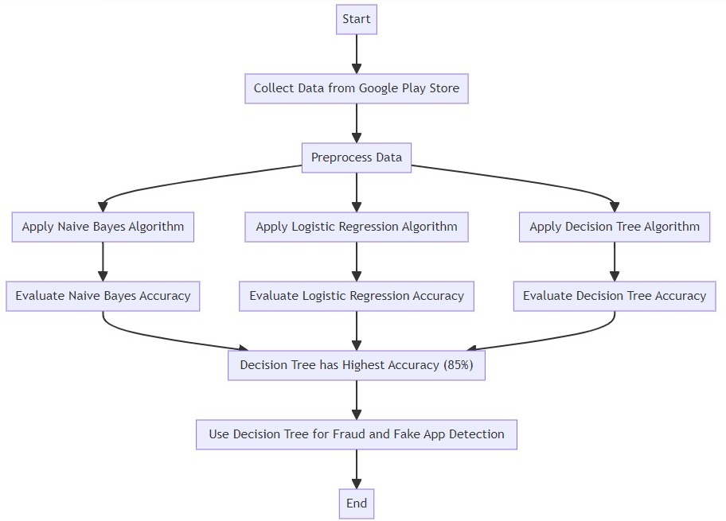

Explanation:
- A data flow diagram is used to graphically describe the flow of data between various processes that are involved in an information system.
- It is one of the most important data modeling tools that help to understand the system, its data, and the transformations associated with it. It can also depict any external entities that work together with this system and show how the data change is due to it.
- It describes what is the input data for each component in the system, what are the transformations that are being applied to the input data, and what is the output data from the component in the system.
- It also gives a logical idea of what is happening in various business processes involved in the system. The data flow diagram can be broken into multiple levels to decrease the abstraction level and show more details that are associated with each component or process of the system and elaborate on the functionality of the system.

CHAPTER 5
ALGORITHMS AND TECHNIQUES
5.1 MODULE:
- Data Collection
- Data pre-processing and filtration
- Model creation and training
- Model Deployment
5.2 MODULES DESCSRIPTION:
5.2.1 Data Collection:
Gathered a dataset comprising 5500 apps from Kaggle and fraudulent app data from various reputable articles.
Utilized Kaggle, a comprehensive platform for dataset sharing, model building, and collaborative data analysis. Leveraged the Jupyter Notebooks environment on Kaggle for seamless dataset exploration, analysis, and model development.
Capitalized on Kaggle's GPU resources and extensive repository of community-contributed data and code.
5.2.2 Data Pre-processing and Filtration:
Conducted essential data cleansing operations, including the removal of missing values and retention of relevant columns.
Employed the powerful pandas library for data analysis and manipulation tasks.
Utilized pandas for data ingestion from diverse formats (e.g., CSV, JSON, Excel) and for tasks like merging, reshaping, and sorting.
Data Collection and Preprocessing:
- We collected an extensive dataset comprising Google Play Store app information, encompassing essential features for fraud detection, such as app category, ratings, reviews, permissions, download count, and developer details.
- Through diligent preprocessing efforts, we effectively handled missing values, encoded categorical variables using one-hot encoding, and ensured numerical feature uniformity through normalization.
5.2.2.1 Feature Selection and Engineering:
- An in-depth analysis of the dataset's features guided our selection of those most pertinent for fraud detection.
- Leveraging our domain knowledge, we engineered new features, including calculated ratios, aggregated data, and binary indicators, enhancing the model's ability to discern subtle patterns.
5.2.2.2 Data Splitting:
- We strategically divided the dataset into a training set (70-80%) for model training and a separate testing set (20-30%) for rigorous evaluation.
5.2.3 Model Creation and Training:
In this phase of the project, three different machine learning algorithms were employed to build predictive models for fraud detection:
Decision Tree, Naïve Bayes and Logistic Regresion for this three algorithms we calculated accuracy , precision , Recall and F1 score.
Accuracy:
Accuracy measures the overall correctness of a model’s predictions.
Accuracy = Total no. of correct predictions/Total no of predictions
Precision:
Precision measures the proportion of true positive predictions out of all positive predictions made by the model. It quantifies how many of the predicted positive instances are actually true positives.
Precision=True Positive/(True Positive + False Positive)
Recall:
Recall measures the proportion of true positive predictions out of all actual positive instances. It quantifies how many of the actual positive instances were correctly predicted as positive.
Recall = True Positive/(True Positive+False Negatives)​
F1 Score:
The f1 score is the harmonic mean of precision and recall.It provies a balance between precision and recall, which is useful when the class distribution is imbalanced.
F1 Score=(2*Precision*Recall)/(Precision+Recall)
Result Analysis
When analyzing the results of machine learning models, especially classification models, it's essential to consider various metrics and aspects of performance. Comparative analysis on different machine learning
Algorithm | Accuracy | Precision | Recall | F1_Score
Decision Tree | 85 | 83 | 80 | 81
Logistic Regression | 78 | 60 | 88 | 60
Navie Bayes | 77 | 58 | 88 | 58
Fig 6.9: Comparison Chart
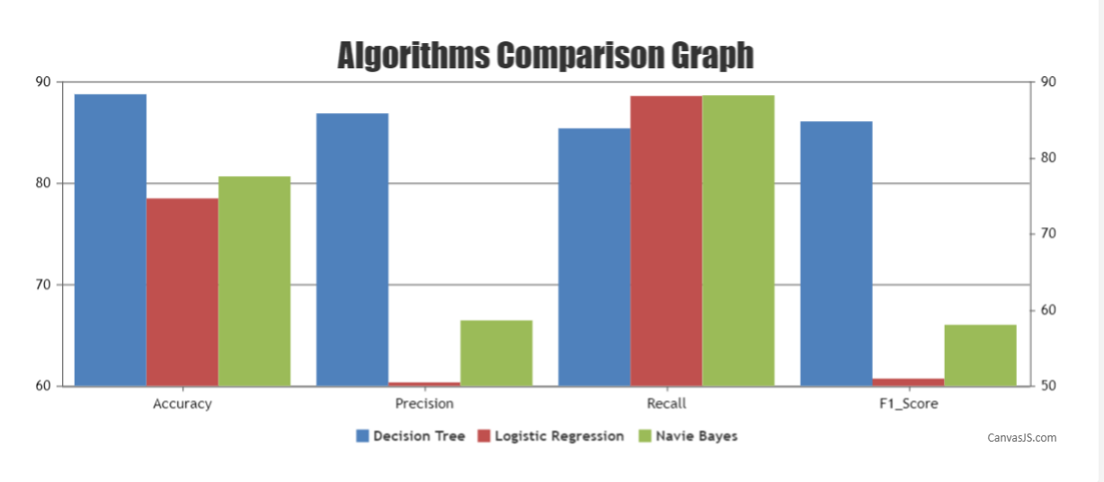 Fig 6.10: Algorithm comparison graph
5.3 AlGORITHM:
5.3.1 Decision Tree Algorithm:
- Opting for the proven scikit-learn Decision Tree implementation, we successfully trained the model on the training dataset using relevant features and the target variable (fraudulent or legitimate app classification).
Model Evaluation:
- Rigorous testing against the dedicated testing dataset allowed us to evaluate the model's performance.
- By employing crucial classification evaluation metrics such as accuracy, precision, recall, F1-score, and AUC-ROC, we comprehensively assessed the model's effectiveness.
Hyperparameter Tuning:
- Through systematic hyperparameter tuning, we determined the optimal configuration for our Decision Tree model.
- Techniques such as grid search and random search enabled us to pinpoint hyper parameters that yielded superior performance.
Model Interpretation:
- Visualizing the Decision Tree's hierarchical structure granted us valuable insights into the feature splits governing the model's decisions.
- Our exploration of feature importance deepened our understanding of the model's decision-making process.
Handling Imbalance:
- Recognizing class imbalance within the dataset, we skillfully applied strategies to counter it.
- Our approach involved the adept use of oversampling, undersampling, and advanced techniques like SMOTE to mitigate the impact of the imbalance.
Decision Tree Algorithm
def decision_tree(req, id):
Accuracy = None
Precision = None
Recall = None
F1_Score = None

# Retrieve the dataset based on the provided 'id'
data = Dataset.objects.get(data_id=id)
file = str(data.data_set)

# Load the dataset into a Pandas DataFrame
df = pd.read_csv('./media/' + file)

# Define input features (x) and the target variable (y)
x = df[['Cleaned_Content', 'Rating']]
y = df['Sentiment']

# Split the dataset into training and testing sets
x_train, x_test, y_train, y_test = train_test_split(x, y, test_size=0.3, random_state=0)

# Convert text data into numerical format using TF-IDF vectorization
tf = TfidfVectorizer()
x_train1 = tf.fit_transform(x_train.Cleaned_Content)
x_test1 = tf.transform(x_test.Cleaned_Content)

# Create a Decision Tree model
model_name = DecisionTreeClassifier()

# Train the model on the training data
model_name.fit(x_train1, y_train)

# Make predictions on the testing data
prediction = model_name.predict(x_test1)

# Calculate performance metrics
Accuracy = accuracy_score(prediction, y_test)
Precision = precision_score(prediction, y_test, average='macro')
Recall = recall_score(prediction, y_test, average='macro')
F1_Score = f1_score(prediction, y_test, average='macro')

# Store the performance metrics in the 'Dataset' object and update the associated algorithm
data.Accuracy = Accuracy
data.Precision = Precision
data.Recall = Recall
data.F1_Score = F1_Score
data.algo = "Decision Tree"
data.save(update_fields=["Accuracy", "Precision", "Recall", "F1_Score", "algo"])
data.save()

# Redirect to the 'score' view with the 'id' parameter
return redirect('score', id)
Explanation:
1.Function Definition:
def decision_tree(req, id):
This function is a Django view for applying the Decision Tree algorithm to a dataset. It takes two parameters: req (the request object) and id (an identifier for the dataset).
2.Initialization of Performance Metrics:
Accuracy = None
Precision = None
Recall = None
F1_Score = None
These variables are initialized as None and will be used to store the performance metrics of the Decision Tree model, including accuracy, precision, recall, and F1 score.
3.Dataset Retrieval:
data = Dataset.objects.get(data_id=id)
This line retrieves the dataset corresponding to the provided id from the database using Django's Object-Relational Mapping (ORM). It assumes that there is a Django model named Dataset with a field named data_id that is used to uniquely identify datasets.
4.File Handling and Data Loading:
file = str(data.data_set)
df = pd.read_csv('./media/' + file)
These lines extract the filename of the dataset and load it into a Pandas DataFrame. The dataset contains features ('Cleaned_Content' and 'Rating') and a target variable ('Sentiment').

5.Data Preparation:
x = df[['Cleaned_Content', 'Rating']]
y = df['Sentiment']
Here, the input features x are defined as a subset of the DataFrame, consisting of 'Cleaned_Content' and 'Rating' columns. The target variable y is defined as the Sentiment' column.
6.Data Splitting:
x_train, x_test, y_train, y_test = train_test_split(x, y, test_size=0.3, random_state=0)
This code segment splits the dataset into a training set and a testing set. It uses 70% of the data for training and 30% for testing, with a random seed of 0 for reproducibility.
7.Text Data Vectorization:
tf = TfidfVectorizer()
x_train1 = tf.fit_transform(x_train.Cleaned_Content)
x_test1 = tf.transform(x_test.Cleaned_Content)
The 'Cleaned_Content' column contains text data. The TF-IDF (Term Frequency-Inverse Document Frequency) vectorization technique is applied using the TfidfVectorizer to convert the textual data into a numerical format.
8.Decision Tree Model Creation:
model_name = DecisionTreeClassifier()
An instance of the Decision Tree classifier, DecisionTreeClassifier, is created to build a decision tree model.
9.Model Training:
model_name.fit(x_train1, y_train)
The Decision Tree model is trained on the training data using the fit method. It learns to make decisions based on the features to predict the 'Sentiment' target variable.
10.Model Prediction:
prediction = model_name.predict(x_test1)
The trained model is used to make predictions on the testing data using the predict method. These predictions are stored in the 'prediction' variable.
11.Performance Metrics Calculation:
Accuracy = accuracy_score(prediction, y_test)
Precision = precision_score(prediction, y_test, average='macro')
Recall = recall_score(prediction, y_test, average='macro')
F1_Score = f1_score(prediction, y_test, average='macro')
These lines calculate several performance metrics to assess the model's accuracy and effectiveness. The metrics include Accuracy, Precision, Recall, and F1 Score.
12.Updating the Dataset Object:
data.Accuracy = Accuracy
data.Precision = Precision
data.Recall = Recall
data.F1_Score = F1_Score
data.algo = "Decision Tree"
data.save(update_fields=["Accuracy", "Precision", "Recall", "F1_Score", "algo"])
data.save()
The calculated performance metrics are stored in a Django model object named 'Dataset,' and the model is associated with the 'Decision Tree' algorithm. The changes are saved to the database.
13.Redirection to the 'score' View:
return redirect('score', id)
Finally, the function redirects the user to the 'score' view, where the model's performance metrics can be displayed and analyzed. This code demonstrates how to train a Decision Tree classifier on a dataset, evaluate its performance, and integrate it into a Django web application for further analysis.
5.4 MODEL DEPLOYMENT:
Developed a user-friendly web interface using the Flask web framework. Implemented a search box where users input an app URL and receive a result indicating whether the app is "fake" or "safe to use." Flask facilitated the creation of a web application by providing essential tools, libraries, and technologies.
By effectively executing these modules, the system seamlessly collects, preprocesses, and analyzes data, creates accurate models for fraud detection, and deploys an intuitive web interface for users to interact with the system's results.
Deployment:
- Our diligently trained Decision Tree model seamlessly transitioned to real-time predictions on fresh app data.
- Robust deployment mechanisms, including APIs and integrations, ensured the model's integration into the fraud detection system.
By executing each step with precision, we accomplished our objective of creating a dependable, adaptable fraud detection system that plays a pivotal role in enhancing user security and trust within the Google Play Store app ecosystem.

CHAPTER 6
EXPERIMENT RESULTS
6.1 INTRODUCTION
This project is implements like application using python and the Server process is maintained using the SOCKET & SERVERSOCKET and the Design part is played by Cascading Style Sheet.
6.2 Home page
This is the starting page of the application when the application is executed on Editor Terminal, the application is hosted on a web and the below page is opened on the browser.


Fig 6.1 Home Page

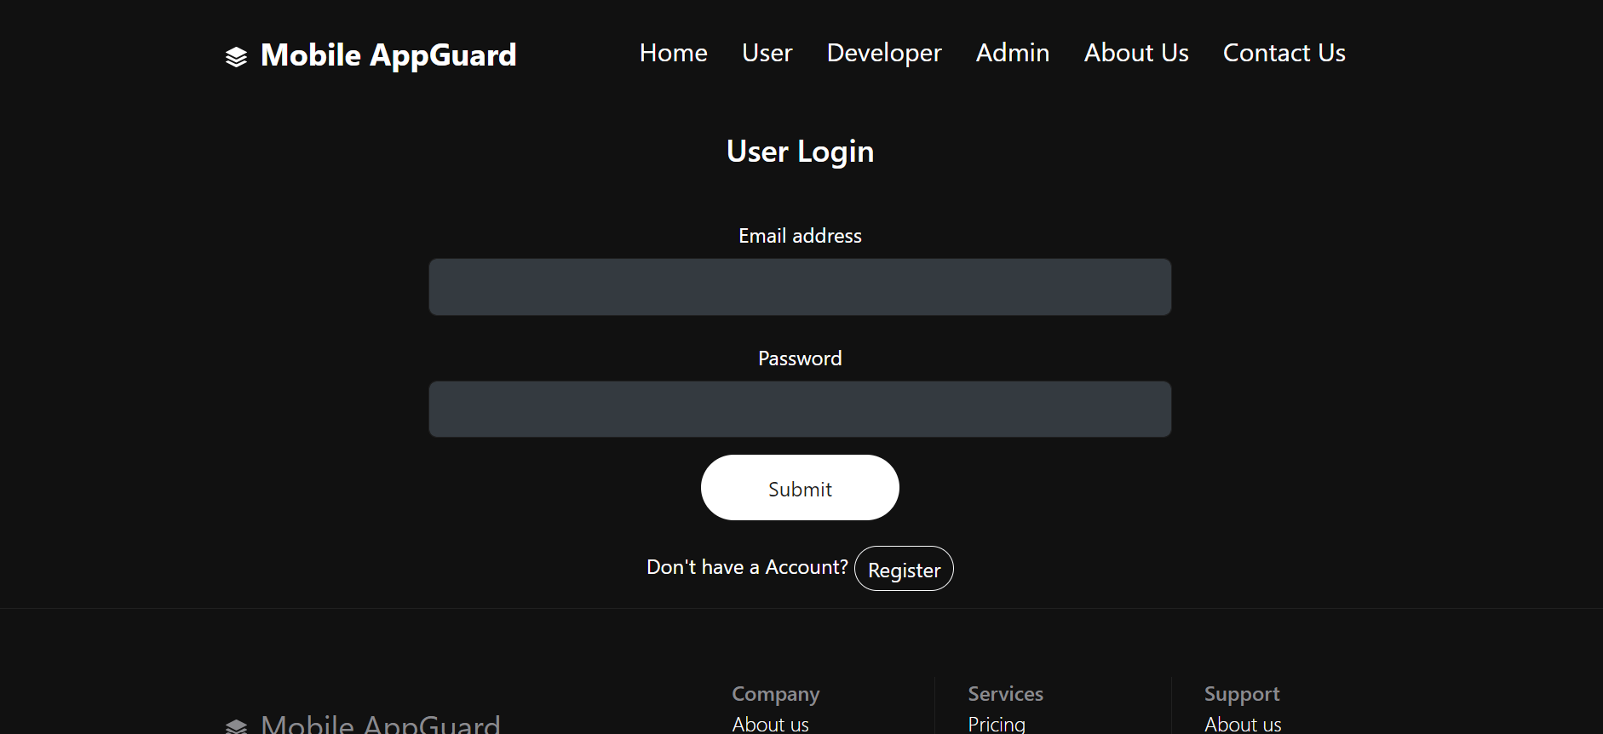
Fig 6.2 User Login Page

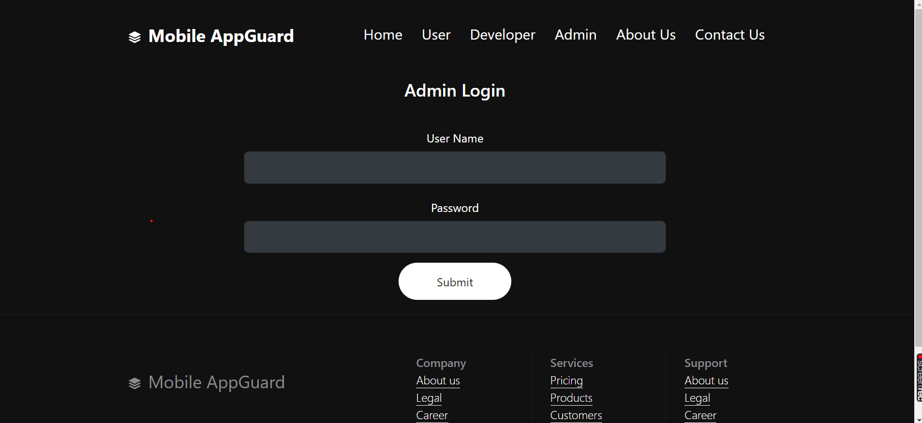
Fig 6.3 Admin Login Page

Fig 6.4 Admin Dashboard

6.3 Upload data set
On this page, the user of the system can upload .csv file. The user has to select the file by clicking on the Choose file button
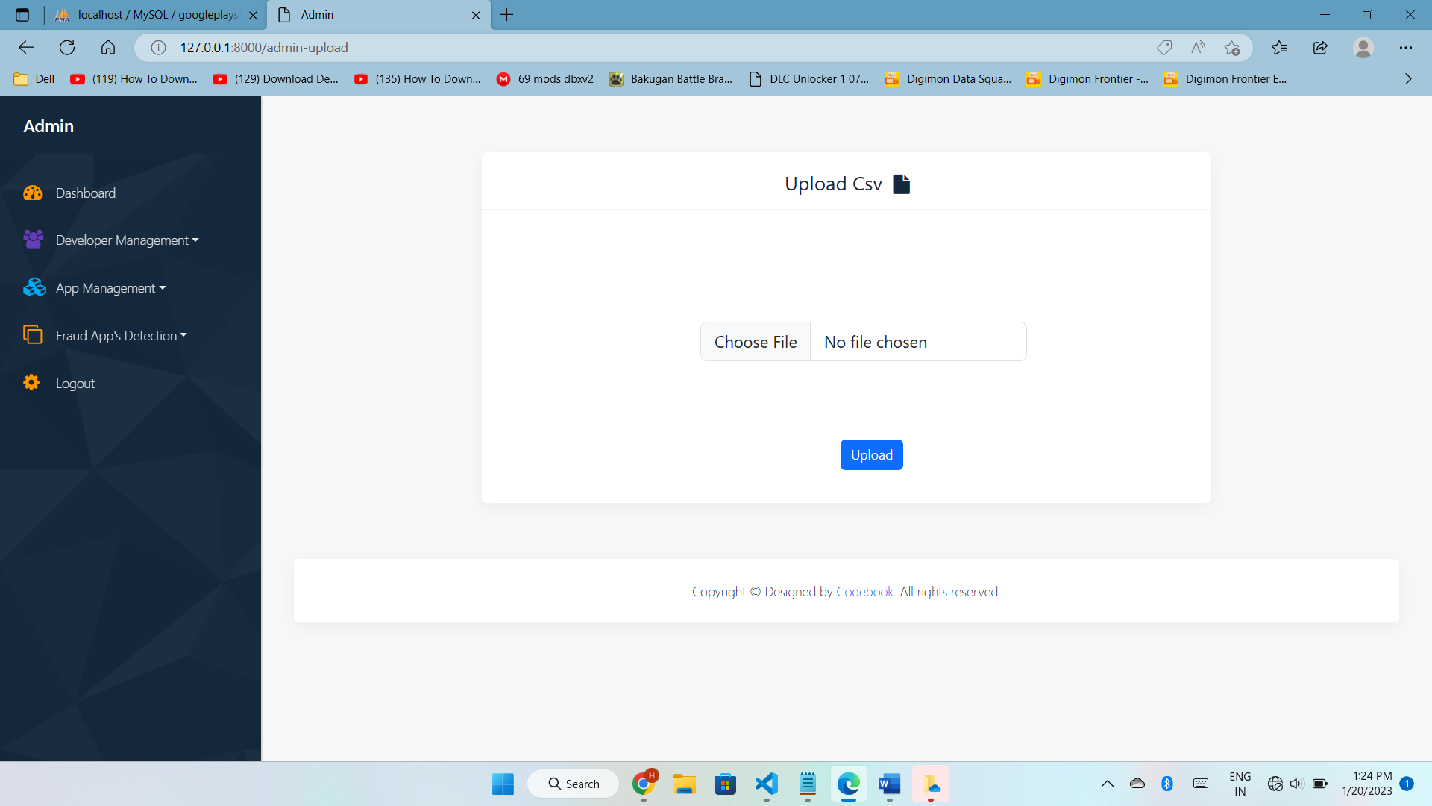
Fig 6.5 Admin Upload Dataset

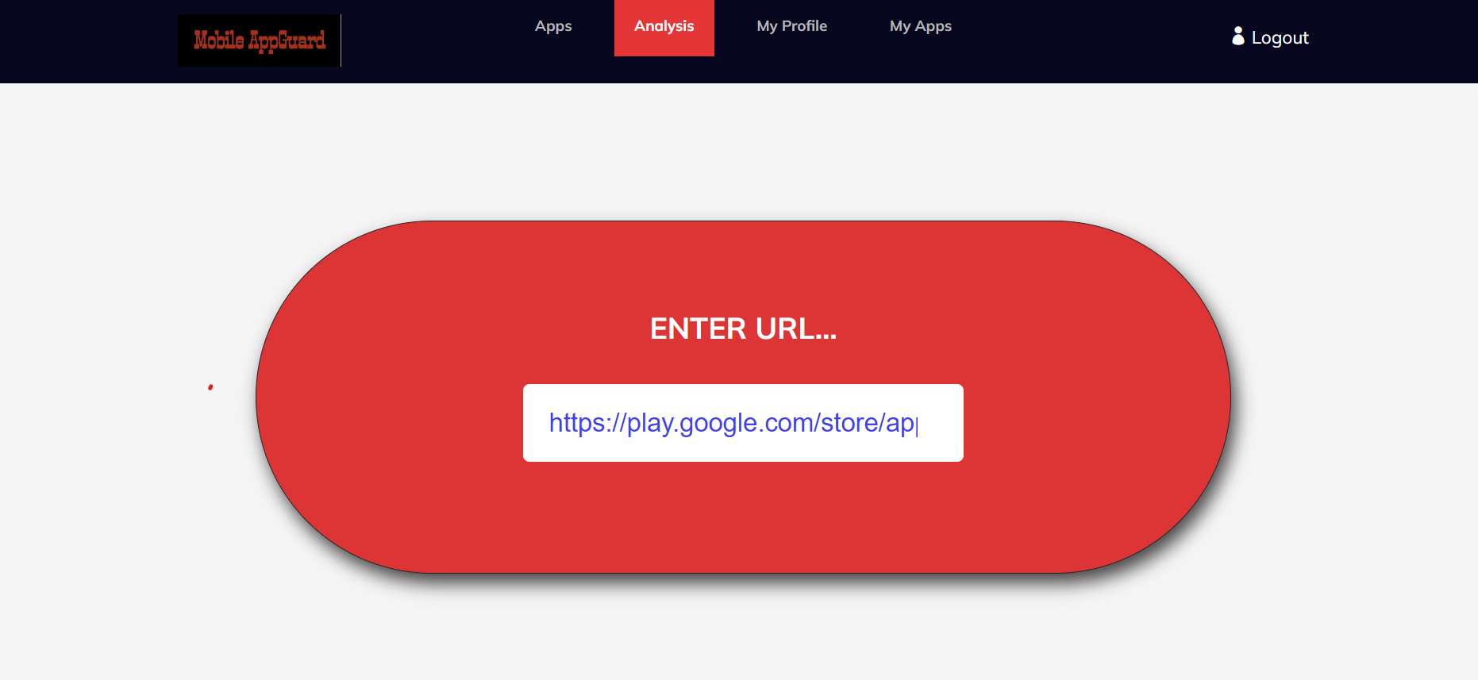
Fig 6.6 Link Upload Page
6.4 Result
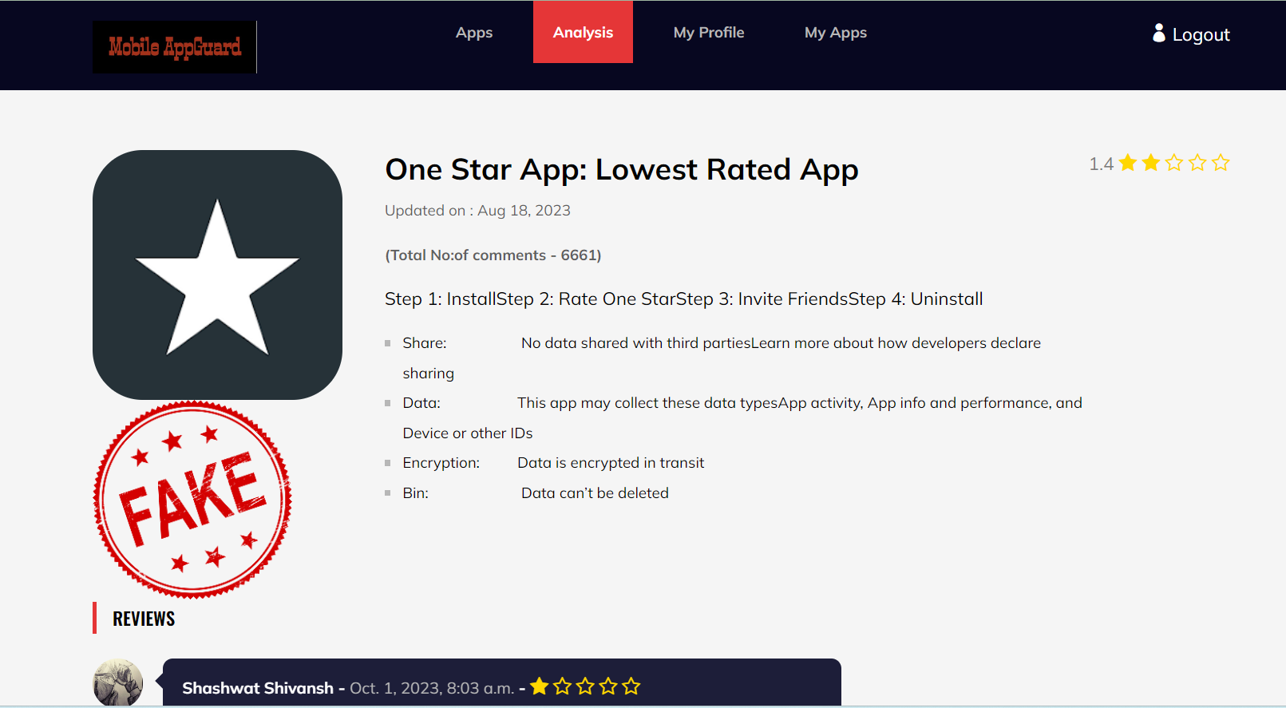
Fig 6.7 Negative Result


Fig 6.8 Positive Result

CHAPTER 7
TESTING
7.1. INTRODUCTION
The process of testing is used to uncover the various faults and errors in the system or the work product. The functionalities of components are checked while testing. It ensures that the system meets its requirements and does not fail during execution. There are many types of tests; each test focuses on different testing requirements. In this unit testing is employed, the test case designs are involved through which the internal program logic is validated and also checks whether valid outputs are produced through program input or not.
7.2 TEST CASES:
Test case 1:
The first test case to test the registration of the user.
Table:7.1 Test Case for Registration
S.No | Test Case | Expected Result | Result | Remarks(if Fail)
1 | User Registered | If User registration done successfully. | Pass | If user is not registered.

Test case 2:
The second test case is done to verify Admin registration and login.
Table 7.2 Test case for Admin login

S.No | Test Case | Expected Result | Result | Remarks(if Fail)
2 | Admin | User rights will be accepted here. | Pass | If user are not registered.

Test case 3:
The third test case pertains to the user login process.
Table 7.3 Test case for user login
S.No | Test Case | Expected Result | Result | Remarks(if Fail)
3 | User Login | If username and password is correct then it will getting valid page. | Pass | If username or password is not correct.

Test case 4:
The fourth test case deals with the fraud detection by fetching the data from Google Play Store.
Table 7.4 Test case for fraud detection
S.No | Test Case | Expected Result | Result | Remarks(if Fail)
4 | Fraud Detection | Fetch data from Google play store. | Pass | If url is invalid.

Test case 5:
The fifth test case deals with comparison of algorithms based on user views.
Table 7.5 Test case for Algorithms
S.No | Test Case | Expected Result | Result | Remarks(if Fail)
5 | User uses naive bayes, Decision Tree, Logistic Regression | User Views algorithm results | Pass | If algorithm details are not available

Test case 6:
The sixth test case is performance analysis.
Table 7.6 Test case for performance analysis
S.No | Test Case | Expected Result | Result | Remarks(if Fail)
6 | Admin | Admin view analysis and charts | Pass | If analysis and charts are not correct.

CHAPTER 8
CONCLUSION AND FUTURE ENHANCEMENT
8.1. CONCLUSION
In today's rapidly advancing technological landscape, the issue of security has emerged as a critical concern. The proliferation of digital platforms has brought about unprecedented conveniences, but it has also given rise to significant security threats. One such challenge is the proliferation of fraudulent applications within Google's app stores. These malicious apps not only jeopardize users' personal privacy and sensitive data but also compromise the overall digital ecosystem's integrity.
In response to this pressing concern, our research endeavors have been meticulously directed towards developing a robust solution for the detection of fraudulent software. We have focused on a comprehensive approach, incorporating four key parameters: app scales, review scores, in-app purchases, and content additions. By analyzing these crucial facets, we aim to effectively distinguish between legitimate applications and those that pose a threat to users.
The cornerstone of our approach lies in the application of advanced algorithms to assess the authenticity of apps. To this end, we conducted a meticulous comparison of three prominent algorithms: Decision Tree, Naive Bayes, and Logistic Regression. Remarkably, our analysis revealed that the Decision Tree algorithm demonstrated the highest accuracy rate, achieving an impressive 85%.
Our proposed framework boasts inherent measurability and scalability, positioning it as a versatile tool for fraud detection across a variety of domains. Its modular design allows for the incorporation of additional domain-specific evidence, further enhancing its efficacy in identifying fraudulent activities. This extensibility underscores the adaptability of our system to future challenges and emerging fraud tactics.
Through rigorous experimentation and empirical analysis, we have successfully demonstrated the potency of our proposed system. The accuracy of the algorithmic detection mechanism, coupled with its measured performance, showcases its potential to serve as a critical tool in combating fraudulent operations. Moreover, our system contributes to standardizing fraud detection operations, streamlining the process of distinguishing between legitimate and malicious applications.
Ultimately, our innovative approach holds promising implications for enhancing app store security. By effectively identifying and rating fraudulent applications, our system contributes to the overall integrity of digital marketplaces. This, in turn, bolsters user confidence, promotes privacy, and safeguards sensitive data. As technology continues to evolve, our research serves as a testament to our commitment to staying at the forefront of security solutions and protecting users in an increasingly interconnected digital world.
8.2 Future Enhancement
In the realm of app security, enhancing our fraud app detection project holds exciting prospects. Beyond Decision trees, advanced models like Random Forest and deep learning could bolster accuracy. Deeper feature engineering, incorporating NLP for app descriptions and analyzing user interactions could yield richer insights. Real-time analysis, transparent AI decisions, and continuous learning are vital for adaptive systems. Integrating user feedback, geolocation data, and cross-platform detection can expand scope. Regulatory and collaboration with experts ensure ethical and effective development. By exploring blockchain and embracing smart contracts, you can fortify app verification. As technology advances, our project has agility and innovation will be essential to combating emerging fraud tactics.
REFERENCES
- Esther Nowroji, Vanitha, “Detection Of Fraud Ranking For Mobile App Using IP Address Recognition Technique”, vol. 4.
- JavvajiVenkataramaiah, BommavarapuSushen, Mano. R, Dr.GladispushpaRathi, “An enhanced mining leading session algorithm for fraud app detection in mobile applications”
- S.R.Srividhya, S.Sangeetha – “A Methodology to Detect Fraud Apps Using Sentiment Analysis”
- Keerthana. B, Sivashankari.K and ShaisthaTabasum.S, “Detecting Malwaresand Search Rank Fraud in Google Search Using Rabin Karp Algorithm”, IJARSE,7(02), 2018, pp.504-527.
- Shashank Bajaj, Nikhil Nigam, PriyaVandana, Srishti Singh, “Detection of fraud apps using sentiment analysis”, International Journal of Innovative Science and Research Technology.
- HarpreetKaur, VeenuMangat and Nidhi, ― “A Survey of Sentiment Analysis techniques”
- International conference on I-SMAC (IoT in Social, Mobile, Analytics and Cloud) (I-SMAC), 2017, pp.921
- Jing Wan, Mufan Liu, Junkai Yi and Xuechao Zhang, “Detecting Spam Webpages through Topic andSemantics Analysis”, IEEE Global Summit onComputer and Information Technology (GSCIT), 2015, pp. 83-92.
- Navdeep Singh, Prashant Kr. Pandey and Mr.Srinivasan, ― “Improved Discovery of Rating Fake for Cellular Apps”, IEEE International Conference on Science Technology Engineering and Management (ICONSTEM), 2016, pp. 135-140.
- Weiman Wang, Restricted Boltzmann Machine. GitHub. Aug 2017. [Online] Available: https://github.com/aaxwaz/Fraud-detection-usingdeep-learning/blob/master/rbm/rbm.py.
- DubeyVeena, G. D. (2016). Sentiment Analysis Based on Opinion Classification Techniques: A Survey .International Journal of Advanced Research in Computer Science and Software Engineering, 5358.
- Ranking fraud Mining personal context-aware preferences for mobile users. H. Zhu, E. Chen, K. Yu, H. Cao, H. Xiong, and J. Tian. In Data Mining (ICDM), 2012 IEEE 12th International Conference on, pages1212–1217, 2012.
- NandimathJyoti, K. B. (2017). Efficiently Detecting and Analyzing SpamReviews Using Live Data Feed. International Research Journal of Engineering and Technology (IRJET) , 1421-1424.
- Detecting product review spammers using rating behaviors. E.-P. Lim, V.-A.Nguyen, N. Jindal, B. Liu, and H. W. LauwIn Proceedings of the 19th ACM international conference on Information and knowledge management, CIKM ‟10 pages 939–948, 2013.
- Detection for mobile apps H. Zhu, H. Xiong, Y. Ge , and E. Chen. A holistic view. In Proceedings of the 22nd ACM international conference on Information and knowledge management, CIKM ‟13, 2013

